MHCO Eviction Moratorium Update May 2021 – After SB 282

[NOTE: Except where explicitly stated otherwise, MHCO’s prior guidance on HB 4401 still applies until July 1, 2021.]

The Oregon Legislature has once again updated the Eviction Moratorium rules for landlords and tenants in response to the continuing Covid emergency. Most recently, in May 2021, the legislature passed Senate Bill 282 which amends certain portions of the earlier House Bills 4213 and 4401.
Background:

House Bill 4213 was the State’s initial response to the Covid-19 emergency. The Bill established an “Emergency Period” commencing on April 1, 2020 and running until September 30, 2020. During the Emergency Period tenants were protected from termination for non-payment of rents, charges, and fees, known as the “Nonpayment Balance.”

4213 further provided tenants with a “Grace Period” running from the end of the Emergency Period on September 30, 2020, until March 31, 2021. During the Grace Period, tenants would still owe their Nonpayment Balance (current rents, charges, and fees) which was due in its entirety by the last day of the Grace Period. Their tenancy could not be terminated for the failure to pay until after the last day of the Grace Period.

Executive Order 20-56 was signed by Governor Brown in late 2020, in recognition that the Covid emergency was continuing. It extended the Emergency Period (the time under HB 4213 in which a tenant could not be evicted for nonpayment) until December 31, 2020. The Governor did not make any changes to the Grace Period. Thus, all outstanding Nonpayment Balances were still due by March 31, 2021.

House Bill 4401 was passed in December 2020 to provide additional relief to tenants and provide a way for the State to mitigate financial damage to landlords. HB 4401 did two main things:
- It authorized the Oregon Department of Housing and Community services to create the Landlord Compensation Fund; and
- It extended the Emergency and Grace Periods to June 30, 2021, for tenants who completed and returned a document known as the “Declaration of Financial Hardship”.

Tenants who gave their landlord the completed and signed Declaration of Financial Hardship were protected from termination for nonpayment of rents, charges, and fees through the Extended Emergency Period, i.e., until June 30, 2021. Likewise, they received similar protection during the Extended Grace Period, meaning their Nonpayment Balance for all rents, charges and fees accruing from April 1, 2020, through June 30, 2021, would not become due until July 1, 2021.

Tenants who DID NOT return a Declaration of Financial Hardship were to begin paying current rents, charges, and fees beginning January 1, 2021, and would have until March 31, 2021, the end of the original Grace Period, to pay off their nonpayment balance. [See, link here.]

Senate Bill 282

Senate Bill 282 was passed in May of 2021. Its primary purpose was to extend the Grace Period for tenants carrying a Nonpayment Balance to February 28, 2022. It also makes slight changes to tenant screening procedures and temporarily disallows terminations and fees for renters having non-tenant guests.

SB 282 was passed as an Emergency measure and therefore all changes go into effect immediately upon the governor’s signature on May 19, 2021. However, changes to the Eviction Moratorium Laws (4213 as modified by 4401), as detailed below, do not take effect until July 1, 2021, unless otherwise noted.

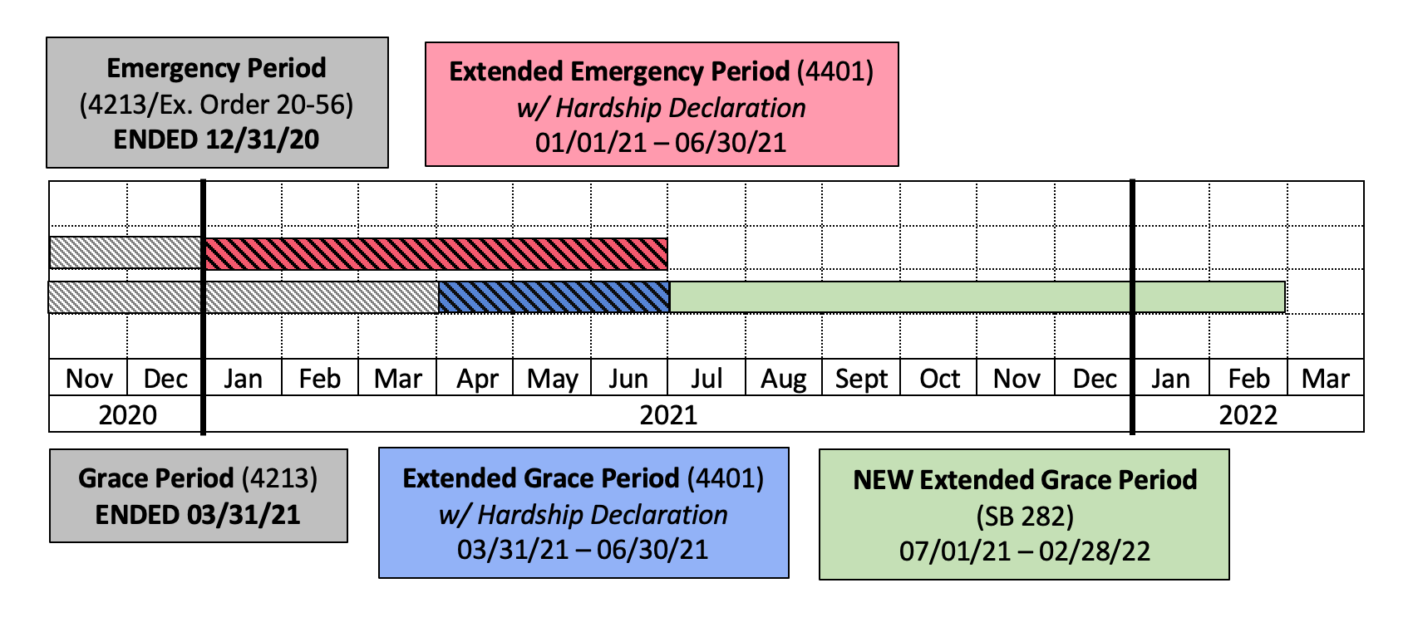
Discussion

- The definition of a “Nonpayment Balance” remains the same. The Nonpayment Balance is all outstanding rents, charges, utilities, and fees that have accumulated during the Original and Extended Emergency Periods, running from April 1, 2020, to June 30, 2021.

- Landlords still may not take the following actions before the end of the New Grace Period (i.e., before February 28, 2022).
  - threatening to terminate a tenant for the Nonpayment Balance,
  - initiating or continuing any FEDs because of the Nonpayment Balance;
  - interfering with a tenant's use or possession of their dwelling unit due to the Nonpayment Balance;
  - assessing late fees or charges because of the Nonpayment Balance; and
  - initiating any legal action to recover the Nonpayment Balance.

- The Grace Period does not excuse tenants from paying their current rents, charges, utilities, and fees, per their lease, on or after July 1, 2021. There has been no extension of the Emergency Period. Landlords have the full selection of state laws for enforcement and recovery available to them for debts arising after July 1, 2021.

- Payments received from, or on behalf of, a tenant must still be applied in the following manner (Note: this differs from the order of application in ORS 90.220(9) (Terms and conditions of rental agreement).
  - First, to rent from the current rental period;
  - Second, to utility or service charges;
  - Third, to late rent payment charges; and
  - Fourth, to fees or charges owed by the tenant under ORS 90.302 (Fees allowed for certain landlord expenses) or other fees or charges related to damage claims or other claims against the tenant.
    - Whatever is left of the payment may be applied to the Nonpayment Balance.

- If a tenancy terminates before the end of the Grace Period, the landlord may apply tenant’s security deposit or last month’s rent toward any remaining Nonpayment Balance.

- Tenants that have an outstanding Nonpayment Balance accrued between April 1, 2020, and June 30, 2021, are not considered in default until after the expiration of the new Grace Period, on February 28, 2022.

- Landlords may still accept partial payments without waiving their right to terminate (a) for cause at any time, or (b) for nonpayment after the expiration of the new Grace Period on February 28, 2022.

What did SB 282 change from HB 4401?

- There is no provision in SB 282 requiring any additional forms or declarations on behalf of a tenant to receive the benefit of the new Grace Period extending to February 28, 2022. Tenants who have not filled out a Declaration of Financial Hardship under HB 4401 will still receive the benefit of the new Grace Period after July 1, 2021.
  - Note: Tenants should still be encouraged to fill out the Declaration prior to June 30, 2021, if a landlord is seeking compensation from the state’s Landlord Compensation Fund.
  - Round Three of the Landlord Compensation Fund will allow landlords to seek reimbursement for tenants who have moved out during the Emergency Period but left behind a Nonpayment Balance. Landlords must have a Declaration of Financial Hardship and a current address for their former tenants to be considered for funding
  - No-cause terminations and evictions are allowed beginning July 1, 2021. If, for the purposes of a no-cause termination, the first year of occupancy would end after April 1, 2020, but before August 31, 2021, the “first year of occupancy” is extended to mean a period lasting until August 31, 2021.

- Landlords may still issue an optional written notice reminding a tenant of their outstanding nonpayment balance. The content of this notice has changed slightly.
  - Notice must state that the tenant continues to owe debt that accrued between April 1, 2020, and June 30, 2021.
  - It also must include a statement that eviction for nonpayment of rent charges and fees accrued between April 1, 2020, and June 30, 2021, is not allowed before February 28, 2022.
  - The notice may include:
    - Information regarding tenant resources;
    - Information on a voluntary payment plan. If the landlord offers a voluntary payment plan, the notice must state that participation is strictly voluntary.
    - A request that the tenant contact the landlord about the voluntary repayment plan.

- Any termination notices for failure to pay rent (ORS 90.394 Termination of tenancy for failure to pay rent) must state that:
  - Eviction for nonpayment of rent, charges and fees that accrued on and after April 1, 2020, and before June 30, 2021, is not allowed before February 28, 2022; and
  - Information regarding tenant resources is available at www.211info.org

- Statute of limitations for claims based on a tenant’s nonpayment or Nonpayment Balance is tolled (i.e., suspended) until March 1, 2022.

- Note: The above changes will expire in March 2022.

Reporting to Consumer Credit Agency – effective beginning May 19, 2021
- Landlords may not report a tenant’s Nonpayment Balance accruing between April 1, 2020, and July 1, 2021, to any consumer credit reporting agency.
  - This is a change from the prior language which only prohibited reporting during the Emergency and Grace Periods.

Tenant Screening (the following are changes to ORS 90.303 Evaluation of applicant) – effective beginning May 19, 2021
- Landlords may not, while evaluating an applicant, consider any general judgments on an action to recover possession (FED) entered against a potential tenant for that arose on or after April 1, 2020, and before March 1, 2022;
- Landlords may not, while evaluating an applicant, consider an applicant’s unpaid rent, including rent reflected in judgments or referrals of debt to a collection agency, that accrued on or after April 1, 2020, and before March 1, 2022;
- These changes expire on January 2, 2028.

Setting Aside an FED Judgment (the following is a change to ORS 105.163 Setting aside judgment) – effective beginning May 19, 2021
- The legislature has allowed FED defendants to have their judgment set aside and their record sealed for certain judgments based on claims arising on or after April 1, 2020, and before March 1, 2022.
- FED defendant still must have satisfied any money award included in the judgment of restitution before their judgment is set aside. These changes expire on January 2, 2028.
Non-Tenant Guests– effective beginning May 19, 2021
- A guest is an individual staying temporarily, including overnight, within the dwelling at the invitation of the tenant.
- SB 282 temporarily prohibits a landlord from enforcing private limitations (including terminating the tenancy or assessing a fee) on the number of guests in a unit or the duration of a guest’s stay.
  - It applies only to landlord limits on the number of guests if they are less than what is allowed by federal, state, or local laws/regulations. For example, if a landlord said a unit could only contain three people, but state regulation would permit four people in the unit, the landlord may not enforce the three-person limit.
- SB 282 also allows for longer-term guests (defined as occupying the dwelling for more than 15-days in any 12-month period) to be subject to:
  - Screening: The landlord may require that they undergo a modified screening process which may not consider creditworthiness (reports or reference) or income; and
  - Temporary Occupancy Agreement: The landlord may require that they enter into a Temporary Occupancy Agreement (ORS 90.275). However, landlord may not require that the T.O. Agreement end prior to the end of the Grace Period (February 28, 2022).
- Termination or fees under 90.302 are available based on unacceptable conduct by the tenant’s guest, or if the guest refuses to submit to the modified screening and Temporary Occupancy Agreement.
- Acceptance of payment from a non-tenant guest does not create a landlord-tenant relationship under ORS Chapter 90.
- Regulations regarding non-tenant guests are automatically repealed on March 1, 2022.

Landlord Permitted Action | Date Permitted Under SB 282  (For any actions before July 1, 2021, consult guidance on HB 4401)
Charge late fees for current month’s rent | July 1, 2021
Serve 72-hr termination notice for non-payment only on a week-to-week tenancy (MHCO Form 85) | July 1, 2021
Serve 72-hour termination notice for non-payment of current month’s rent on an RV or Park-owned Home and Space Rental (MHCO Form 82) | July 1, 2021  [Note: after July 1, 2021, the moratorium’s mandated 10-day notice returns to the normal 72-hour notice under ORS 90.394]
Serve 72-hour termination notice for non-payment of current month’s rent on a tenant-owned Mobile Home or Floating Home (MHCO Form 42) | July 1, 2021  [Note: after July 1, 2021, the moratorium’s mandated 10-day notice returns to the normal 72-hour notice under ORS 90.394]
Serve any termination notice for the “Nonpayment Balance” (i.e., the rent, fees and utilities accrued between April 1, 2020, and June 30, 2021) | March 1, 2022
Refuse to renew a tenancy and/or terminate a tenancy for no-cause | July 1, 2021  [Note: If first year of occupancy would have ended between April 1, 2020, and August 31, 2021, August 31, 2021, is considered the end of the first year.]
Serve a 90-day termination notice for a “Qualified Landlord Reason” (ORS 90.427(5)) | Anytime
Terminate a tenancy for-cause | Anytime
Report nonpayment balance to a credit reporting agency for debt arising between April 1, 2020, and July 1, 2021 | Never  [Note: prohibition on reporting Nonpayment Balance to credit agencies went into effect upon passage of SB 282 on May 19, 2021]
Report non-payment to a credit reporting agency for debt arising after July 1, 2021. | Anytime
File an action to recover the non-payment balance | March 1, 2022

